Chapter 9 programming Random Walk

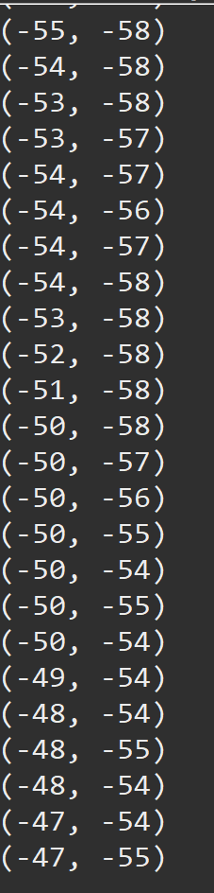First time trying it out never was able to find (0,0) Second time running it never reached (0, 0)

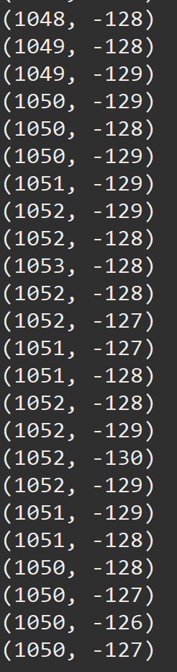

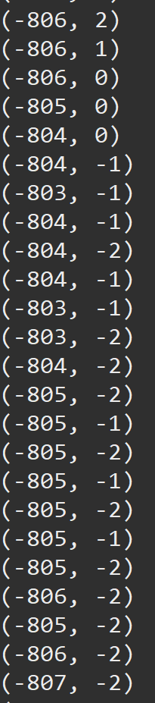Third time running it never reached (0, 0) Fourth time running it never reached (0, 0)

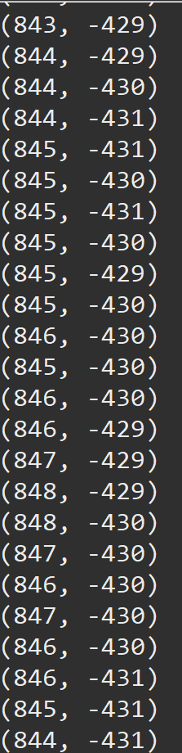

Fifth time running it never reached (0,0) Six time running it never reached (0, 0)

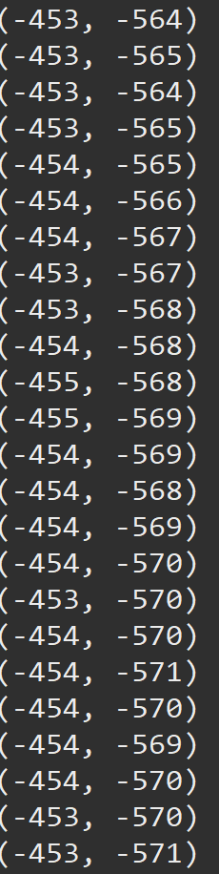

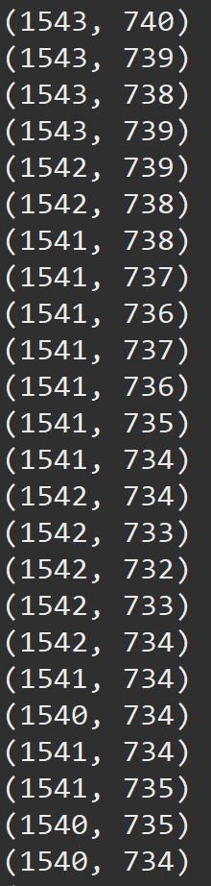

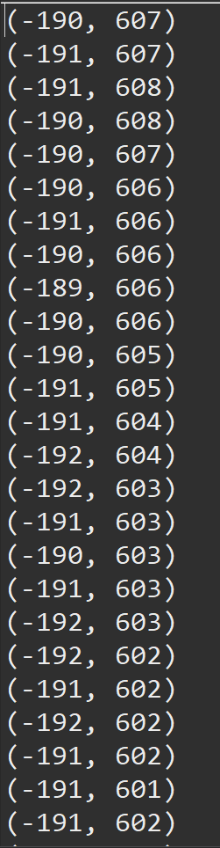Seventh time running it never reached (0, 0) Eighth time running it never reached (0, 0)

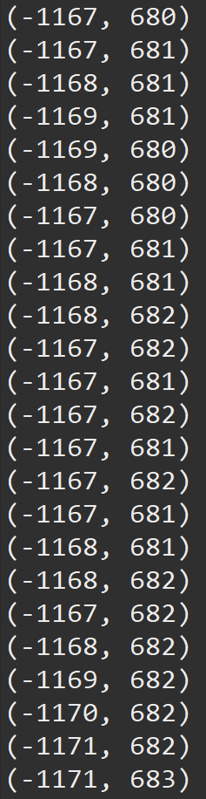

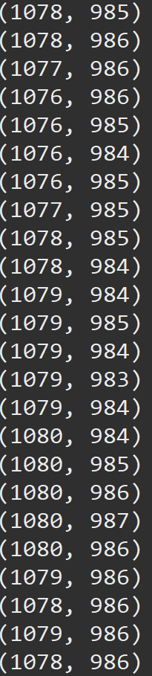Ninth time running it never reached (0, 0) Tenth time running it never reached (0, 0)

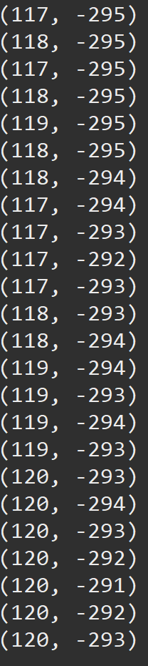

Let each of them run about a minute and none of the were able to get back to (0, 0). About what I expected, if it ever were to get back, I feel like it would’ve had to been really early on.